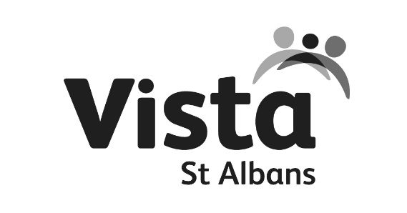

TRADED SERVICE
PARENT REFERRAL FORM
This form should be used when a child or young person has a need which requires a response
from a member of St Albans Plus Schools Partnership Team.
For Child Protection referrals use the Hertfordshire Child Protection Referral Form or ring 0300 123 4043.

WHICH SERVICE ARE YOU REQUESTING?

Counselling |  |  | Mentoring |  | Parent Support
EHCPlan Support (SEN School Family Worker) |  |  | Other |  | Protective Behaviours
WHAT IS THE REASON FOR YOUR REFERRAL/ SUMMARY OF CONCERNS

PARENT NAME |  | PARENT TEL.  PARENT EMAIL:
CHILD/YOUNG PERSON FIRST NAME |  | DATE OF BIRTH
CHILD/YOUNG PERSON SURNAME |  | YEAR GROUP
SCHOOL |  | GENDER | MALE FEMALE
ADDRESS |  | DISABILITY
ETHNICITY |  | CHILDS FIRST LANGUAGE

OTHER SERVICES INVOLVED WITH THE CHILD
 | CONTACT DETAILS | WHAT WORK IS CURRENTLY BEING UNDERTAKEN WITH THE NAMED CHILD OR FAMILY

ADDITIONAL INFORMATION
Please detail any behaviours observed and experienced and impact on own and others academic progress if appropriate

CONSENT

Consent and Information sharing – Parental consent is required to enable information sharing with the identified service. Young people should be aware of the request for a service and be asked for their consent. You will need to make a professional judgement about the young person’s understanding of giving consent.

- I understand that the information contained in this form will be shared with The St Albans Plus Local Partnership team
- I agree to the request and give consent for the service to work with my child/ren and/or me as parent/carer
- I understand that I can withdraw consent at any time

PARENT/CARER SIGNATURE
DATE

IF CONSENT HAS NOT BEEN OBTAINED, PLEASE GIVE A REASON

PLEASE RETURN THIS FORM TO:
Post:  JO MAHER  ST ALBANS PLUS LOCAL SCHOOLS PARTNERSHIP | Email: vistastalbans@gmail.com | Tel: 07939 111152

For help and assistance filling in this form, please contact Vista St Albans CIC: vistastalbans@gmail.com
All staff are DBS checked and attend regular safeguarding training as well as their relevant qualifications.
Vista is GDPR compliant. Our ICO registration number is ZA354653. Personal information taken by our professionals may include session notes, contact records, emails or texts. Your electronic details will be kept securely and will be deleted at the end of every academic year. However paper data may be kept for up to 7 years if a legal requirement.

