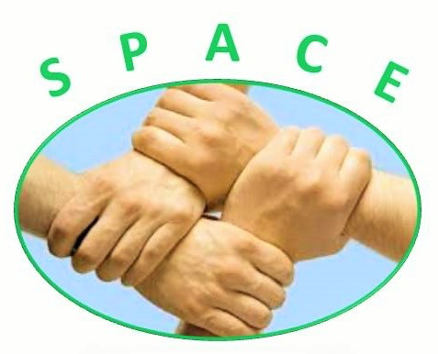
www.spaceherts.org.uk
https://www.facebook.com/groups/523248431177965/
**Dates For Your Diary 2017 - For The St Albans Group**
St Albans Girls School (STAGS)
We meet on the second Friday of the month (term time only) between 10.00am and 12.00pm

March 10th – Amy Belfield & Kelly Shaw DSPL7 Autism Support Workers
APRIL NO MEETING DUE TO EASTER HOLIDAYS
May 12th – Lydia Ebsworth Team Leader at The Owl Centre services for speech, language & communication difficulties and Occupational Therapy.
June 9th – Stacey Smith from SNAP (St Albans Mencap)
July 14th – Emma Paisley Wellbeing Access Worker for the Wellbeing Team
AUGUST NO MEETING DUE TO SUMMER HOLIDAYS
September 8th – Steph Curtis PDA

October 13th - Reece Goldsmith of Goldsmith Mancusso Education and Mentoring & Greenlight specialist youth group

November 10th – Sally Glossop Communication and Autism Team (CATS)

December 8th – Caroline Penn from HANDLE (Holistic Approach to NeuroDevelopmental and Learning Efficiency)

The St Albans group is supported by DSPL7

