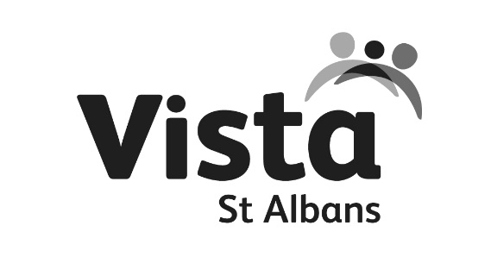

TRADED SERVICE
PARENT REFERRAL FORM
This form should be used when a child or young person has a need which requires a response
from a member of St Albans Plus Schools Partnership Team.

WHICH SERVICE ARE YOU REQUESTING?
Counselling |  |  | Mentoring |  | EHCPlan Support (SEN School Family Worker)
Other

WHAT IS THE REASON FOR YOUR REFERRAL?
WHAT ARE THE DESIRED OUTCOMES FOR YOUR CHILD? | 1  2  3

CHILD’S NAME |  | DATE OF BIRTH
ADDRESS |  | GENDER | MALE FEMALE
PARENT NAME |  | PARENT EMAIL
PARENT TEL. |  | PARENT MOBILE
CHILDS FIRST LANGUAGE |  | DISABILITY
ETHNICITY |  | SEN? | YES NO

OTHER SERVICES INVOLVED WITH THE CHILD
 | CONTACT DETAILS | WHAT SERVICES ARE CURRENTLY WORKING WITH YOUR CHILD OR FAMILY

ADDITIONAL INFORMATION
Please detail any behaviours observed and experienced and impact on own and others academic progress if appropriate

CONSENT

Consent and Information sharing – Parental consent is required to enable information sharing with the identified service. Young people should be aware of the request for a service and be asked for their consent. You will need to make a professional judgement about the young person’s understanding of giving consent.

- I understand that the information contained in this form will be shared with The St Albans Plus Local Partnership team
- I agree to the request and give consent for the service to work with my child/ren and/or me as parent/carer
- I understand that I can withdraw consent at any time

PARENT/CARER SIGNATURE
DATE
YOUNG PERSON SIGNATURE (IF REQUIRED)
DATE

PLEASE RETURN THIS FORM TO:
Post:  JO MAHER  ST ALBANS PLUS LOCAL SCHOOLS PARTNERSHIP | Email:  Jo.maher@fleetvillejm.herts.sch.uk | Tel:  07939 111152

For help and assistance filling in this form, please contact Vista St Albans CIC: vistastalbans@gmail.com
All staff are DBS checked and attend regular safeguarding training as well as their relevant qualifications.

